String and StringBuffer in Java

String

A string is a sequence of characters. One of the most important characteristics of a string in Java is that they are immutable. In other words, once created, the internal state of a string remains the same throughout the execution of the program. This immutability is achieved through the use of a special string constant pool in the heap. In this article, we will understand about the storage of the strings.
A string constant pool is a separate place in the heap memory where the values of all the strings which are defined in the program are stored. When we declare a string, an object of type String is created in the stack, while an instance with the value of the string is created in the heap. On standard assignment of a value to a string variable, the variable is allocated stack, while the value is stored in the heap in the string constant pool.
StringBuffer

Java StringBuffer class is used to create mutable (modifiable) String objects. The StringBuffer class in Java is the same as String class except it is mutable i.e. it can be changed.

Differences between String and StringBuffer Classes

String | StringBuffer
String class is immutable. | StringBuffer class is mutable.
String class is slower while performing concatenation operation. | StringBuffer class is faster while performing concatenation operation.
String class uses String constant pool. | StringBuffer uses Heap memory
String class overrides the equals() method of Object class. So you can compare the contents of two strings by equals() method. | StringBuffer class doesn't override the equals() method of Object class.
String is slow and consumes more memory when we concatenate too many strings because every time it creates new instance. | StringBuffer is fast and consumes less memory when we concatenate t strings.

String Constant Pool

String str1 = "Hello";
String str2 = "Hello";
String str3 = "Class";

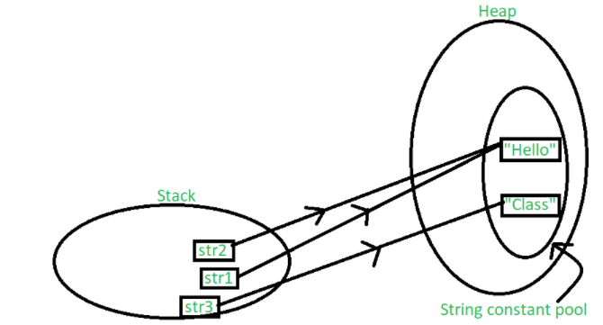
String str1 = new String("John");
String str2 = new String("Doe");
